SIMATS ENGINEERING (SAVEETHA SCHOOL OF ENGINEERING)
Department of Artificial Intelligence and Data Science
ASSESSMENT TOOL 3 – CODING CHALLENGE

Course Code: | DSA0307 | Course Title: | Natural Language Processing
CO Assessed: | CO1 – Imitation (L1) | Assessment: | Assessment Tool 3 – Coding Challenge
Weightage: | 30% of CIA
CO5 Statement: | Analyse NLP models, regular expression patterns, finite state automata, morphological processing techniques and to interpret language processing. (BL-3)
Student Name: | S.Sri Sai Prasanna Durga | Reg. No.: | 192424241
Section / Batch: | 2024 | Date:

Code of Conduct
I __S.Sri Sai Prasanna Durga(192424241)___ (Name / Reg No) certify that this submission is my original work and that I have adhered to the guidelines specified for this assessment. I understand that any violation of academic integrity rules will result in disciplinary action.
Signature of the Student: _Sai Prasanna__________

Instructions
- Develop a complete and modular Python program that meets all the functional requirements specified in the coding challenge using appropriate algorithms, data structures, and programming practices.
- Test the program using multiple valid and invalid test cases, and clearly display the input, processing, and output to verify the correctness of the implementation.
- Follow standard coding practices by using meaningful variable names, proper indentation, comments, exception handling (where applicable), and upload the source code, sample outputs, and README file to the designated GitHub repository.
- Duration: 40 minutes.

Section / Topic | Focus | Q Nos
Regular Expression Pattern Matching | Regular Expressions, Basic Regular Expression Patterns | 1
Finite State Automata Implementation | Finite State Automata, Models and Algorithms | 2
Advanced Regular Expression Search | Regular Expressions, Basic Regular Expression Patterns | 3

Annexure A – Coding Challenge

Section 1: Intelligent Email and Password Validator using Regular Expressions
- Problem Statement:
A software company is developing a user registration system. Before creating an account, the system must validate user credentials based on predefined security policies.

Develop a Python application that validates:
Email Address
Password
Mobile Number

using Regular Expressions.

Validation Rules
Email
Must start with an alphabet.
May contain letters, digits, '.', '_' before '@'.
Domain should contain only alphabets.
Valid extensions: .com, .org, .edu, .net, .in
Password
Minimum 8 characters
At least one uppercase letter
At least one lowercase letter
At least one digit
At least one special character (@,#,$,%,&,!)
Mobile Number
Must contain exactly 10 digits.
First digit should be between 6–9.
Expected Output

Display:

Valid Email / Invalid Email
Strong Password / Weak Password
Valid Mobile Number / Invalid Mobile Number

Section 2: Design a Finite State Automata (FSA) Simulator
- Problem Statement

Develop a Python-based Deterministic Finite Automata (DFA) simulator.

The program should:
- Accept the DFA description
    - States
    - Input alphabet
    - Transition table
    - Initial state
    - Final state(s)
- Accept multiple input strings.
- Simulate state transitions.
- Display whether the string is Accepted or Rejected.
Example

Language:
Strings ending with "ab"

Input
abaab

Output
Transition Path:
q0 → q1 → q0 → q1 → q2
Accepted
Section 3: Smart Pattern Matching Engine using Regular Expressions
- Problem Statement

Develop a Python-based text search engine that performs pattern matching using Regular Expressions.

The system should support:
Word Search
Prefix Search
Suffix Search
Date Search
Phone Number Search
Hashtag Search
Mention (@username) Search

Example Input
Meeting on 12/09/2026
Call 9876543210
#NLP
@OpenAI
natural language processing

User Menu
1.Search Date
2.Search Phone Number
3.Search Hashtag
4.Search Mention
5.Search Prefix
6.Search Suffix

Expected Output
Display all matching patterns based on user selection.

Q1: Intelligent Email and Password Validator using Regular Expressions
1.Problem Understanding:
The objective of this problem is to develop a Python application that validates an Email Address, Password, and Mobile Number using Regular Expressions. The program must verify whether each input satisfies the specified validation rules before accepting it.
The email address must start with an alphabet, may contain letters, digits, dots (.) and underscores (_) before the '@' symbol, the domain should contain only alphabets, and the extension must be one of .com, .org, .edu, .net, or .in.
The password must contain a minimum of 8 characters, at least one uppercase letter, one lowercase letter, one digit, and one special character from (@, #, $, %, &, !).
The mobile number must contain exactly 10 digits, and the first digit should be between 6 and 9.
The program should correctly display whether the Email is Valid or Invalid, the Password is Strong or Weak, and the Mobile Number is Valid or Invalid.
2.Algorithm:
Step 1: Read the Email Address, Password, and Mobile Number from the user.
Step 2: Define separate Regular Expression patterns for Email, Password, and Mobile Number.
Step 3: Compare the Email with the Email Regular Expression pattern.
Step 4: If the Email matches the pattern, display "Valid Email"; otherwise, display "Invalid Email".
Step 5: Compare the Password with the Password Regular Expression pattern.
Step 6: If the Password satisfies all conditions, display "Strong Password"; otherwise, display "Weak Password".
Step 7: Compare the Mobile Number with the Mobile Number Regular Expression pattern.
Step 8: If the Mobile Number is valid, display "Valid Mobile Number"; otherwise, display "Invalid Mobile Number".
Step 9: Display the validation results.
3.Code Implementation:
Code:
import re
email = input("Enter Email: ")
password = input("Enter Password: ")
mobile = input("Enter Mobile Number: ")
email_pattern = r'^[A-Za-z][A-Za-z0-9._]*@[A-Za-z]+\.(com|org|edu|net|in)$'
password_pattern = r'^(?=.*[A-Z])(?=.*[a-z])(?=.*\d)(?=.*[@#$%&!]).{8,}$'
mobile_pattern = r'^[6-9][0-9]{9}$'
if re.fullmatch(email_pattern, email):
print("Valid Email")
else:
print("Invalid Email")
if re.fullmatch(password_pattern, password):
print("Strong Password")
else:
print("Weak Password")
if re.fullmatch(mobile_pattern, mobile):
print("Valid Mobile Number")
else:
print("Invalid Mobile Number")
Output:
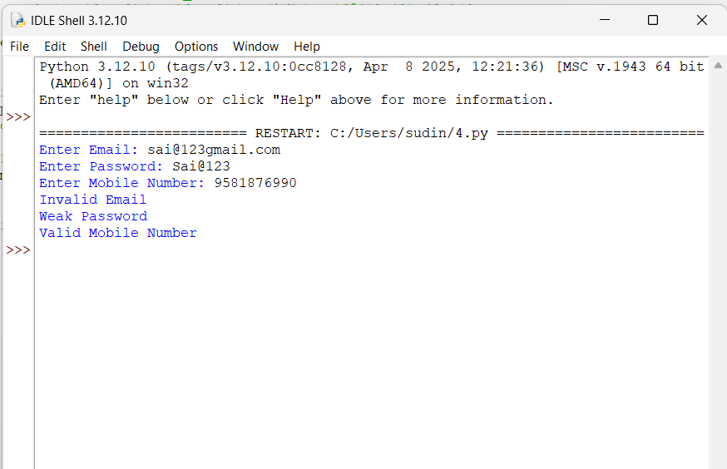
4.Competitive Performance:
The solution is efficient because each input is validated only once using Regular Expressions. The execution time is very low, memory usage is minimal, and no unnecessary loops or repeated computations are performed. The program is capable of validating multiple user inputs quickly while maintaining high performance.
5.Test Case Handling:
The program should be tested with both valid and invalid inputs.
Valid Test Cases
- Email: abc@gmail.com
- Email: student_01@test.in
- Password: Abcd@123
- Password: Welcome#2026
- Mobile Number: 9876543210
- Mobile Number: 8123456789
Invalid Test Cases
- Email: 1abc@gmail.com
- Email: abc@gmail.xyz
- Password: abc12345
- Password: ABCD1234
- Password: Abcd1234
- Mobile Number: 5678901234
- Mobile Number: 987654321
- Mobile Number: 98765432101
These test cases verify that the program correctly handles both normal and edge-case inputs.

Q2: Design a Finite State Automata (FSA) Simulator
1.Problem Understanding:
The objective of this problem is to implement a Deterministic Finite Automata (DFA) simulator in Python. The program should accept the DFA components, including the states, input alphabet, transition table, initial state, and final state(s). It should process multiple input strings, display the transition path for each character, and determine whether the input string is Accepted or Rejected according to the DFA rules.
2.Algorithm:
Step 1: Define all DFA components.
Step 2: Read the input string.
Step 3: Initialize the current state with the starting state.
Step 4: Read one character at a time from the input string.
Step 5: Use the transition table to move to the next state.
Step 6: Store every state transition.
Step 7: After processing all characters, check whether the final state is an accepting state.
Step 8: Display the transition path.
Step 9: Display Accepted if the final state is an accepting state; otherwise, display Rejected.
3.Code Implementation:
Code:
transitions = {
'q0': {'a': 'q1', 'b': 'q0'},
'q1': {'a': 'q1', 'b': 'q2'},
'q2': {'a': 'q1', 'b': 'q0'}
}
start_state = 'q0'
final_states = ['q2']
while True:
string = input("\nEnter Input String: ")
current_state = start_state
path = [current_state]
valid = True
for symbol in string:
if symbol not in ['a', 'b']:
valid = False
break
current_state = transitions[current_state][symbol]
path.append(current_state)
if not valid:
print("Invalid Input! Only a and b are allowed.")
else:
print("Transition Path:")
print(" -> ".join(path))

if current_state in final_states:
print("Accepted")
else:
print("Rejected")
ch = input("\nTest Another String? (yes/no): ")
if ch.lower() != "yes":
break
Output:
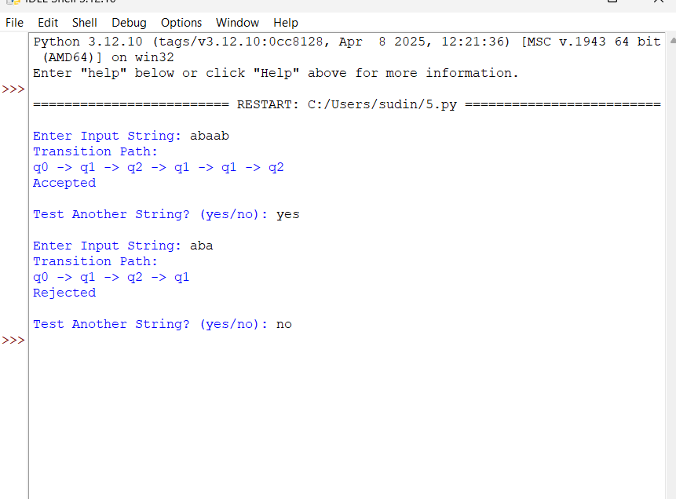
4.Competitive Performance:
The DFA simulator processes each character only once, resulting in linear time complexity O(n). The program uses minimal memory and efficiently handles both short and long input strings. Since the transitions are deterministic, the execution is fast and suitable for competitive programming.
5.Test Case Handling:
Accepted Test Cases
- ab
- aab
- aaab
- bab
- abaabab
Rejected Test Cases
- aa
- ba
- abb
- aaaa
- bbbb
Edge Test Cases
- Empty string
- Single character
- Invalid symbols
- Very long input string
Testing all these cases ensures the correctness and reliability of the DFA simulator.

Q3: Smart Pattern Matching Engine using Regular Expressions
1.Problem Understanding:
The objective of this problem is to develop a Python-based text search engine that performs pattern matching using Regular Expressions. The program should search for Dates, Phone Numbers, Hashtags, Mentions (@username), Prefixes, Suffixes, and Words based on the user's menu selection. It should display all matching patterns found in the given text.
2.Algorithm:
Step 1: Read the input text from the user.
Step 2: Display the search menu.
Step 3: Read the user's menu choice.
Step 4: Select the appropriate Regular Expression pattern based on the selected option.
Step 5: Use re.findall() to search the text.
Step 6: Display all matching results.
Step 7: If no pattern is found, display an appropriate message.
3.Code Implementation:
Code:
import re
text = input("Enter Text: ")
while True:
print("\n------ MENU ------")
print("1. Search Date")
print("2. Search Phone Number")
print("3. Search Hashtag")
print("4. Search Mention")
print("5. Search Prefix")
print("6. Search Suffix")
print("7. Exit")
choice = int(input("Enter Choice: "))
if choice == 1:
print(re.findall(r'\b\d{2}/\d{2}/\d{4}\b', text))
elif choice == 2:
print(re.findall(r'\b[6-9]\d{9}\b', text))
elif choice == 3:
print(re.findall(r'#\w+', text))
elif choice == 4:
print(re.findall(r'@\w+', text))
elif choice == 5:
prefix = input("Enter Prefix: ")
print(re.findall(r'\b' + prefix + r'\w*', text))
elif choice == 6:
suffix = input("Enter Suffix: ")
print(re.findall(r'\b\w*' + suffix + r'\b', text))
elif choice == 7:
print("Program Ended")
break
else:
print("Invalid Choice")
Output:
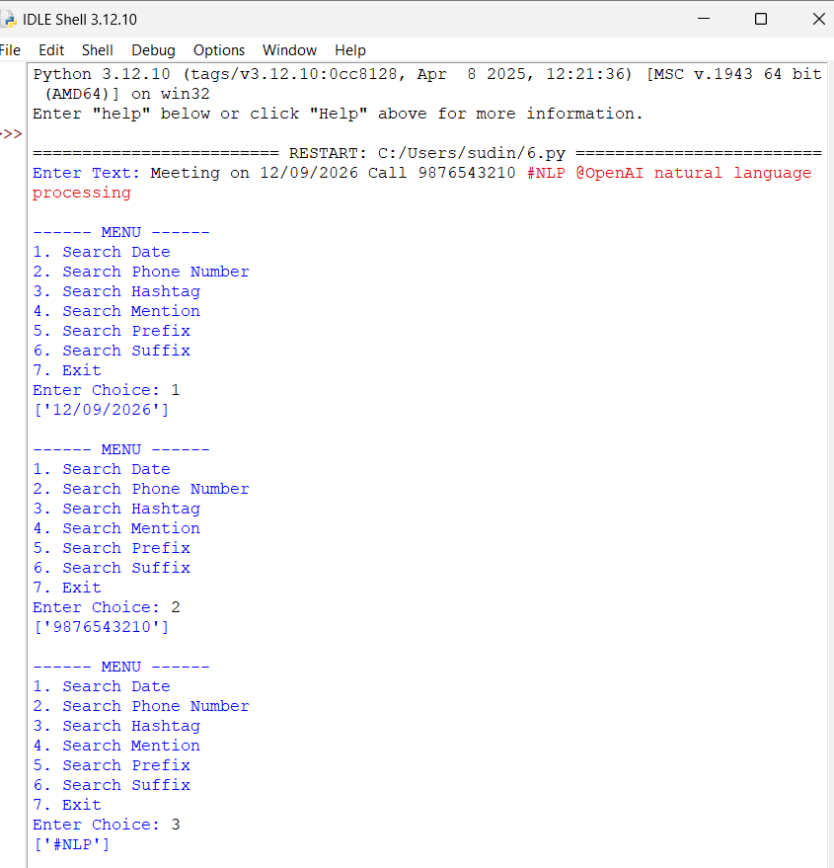
4.Competitive Performance:
The program performs only one Regular Expression search for each user selection, resulting in efficient execution. The algorithm has linear time complexity O(n), uses minimal memory, and can efficiently process large text inputs while maintaining good performance.
5.Test Case Handling:
Valid Test Cases
Input Text:
- Meeting on 12/09/2026
- Call 9876543210
- #NLP
- @OpenAI
- natural language processing
Expected Results:
- Date → 12/09/2026
- Phone Number → 9876543210
- Hashtag → #NLP
- Mention → @OpenAI
- Prefix → Matching prefix words
- Suffix → Matching suffix words
Edge Test Cases
- No matching pattern
- Multiple dates
- Multiple phone numbers
- Multiple hashtags
- Multiple mentions
- Empty input
- Special characters only
Testing these scenarios ensures that the pattern matching engine correctly handles both standard and edge-case inputs.

Rubrics for Calculation
Criteria | Weightage | Level 4 – Exemplary | Level 3 – Proficient | Level 2 – Developing | Level 1 – Beginning
Problem Understanding | 20% | Clearly understands problem constraints, edge cases, and competitive requirements | Understands problem with minor gaps in constraints | Partial understanding; misses key constraints | Misinterprets problem or constraints
Algorithm | 25% | Selects optimal algorithm with best time and space complexity for competitive constraints | Uses efficient algorithm with minor scope for improvement | Uses basic/inefficient approach | No clear algorithmic approach
Code Implementation | 20% | Writes correct, efficient, and clean code that passes all constraints | Code works with minor errors or inefficiencies | Partially correct code; fails for some cases | Code does not execute or gives incorrect results
Competitive Performance | 20% | Solves problem within time limits and handles large inputs effectively | Solves within acceptable time with minor delays | Struggles with time limits or larger inputs | Unable to solve within time constraints
Test Case Handling | 15% | Handles all test cases including edge and hidden cases | Handles most test cases | Misses important edge cases | Fails on multiple test cases

Q. No. / Criteria | Problem Understanding | Algorithm | Code Implementation | Competitive Performance | Test Case Handling | Sub. Total | Total %
1
2
3

Faculty In-charge | Course Coordinator | Program Director
Signature: _______________ | Signature: _______________ | Signature: _______________
Date: ___________________ | Date: ___________________ | Date: ___________________

